**Chestnut**

The Autumn Festival at [Ōkunitama Jinja Shrine](https://tokyocheapo.com/place/okunitama-shrine/) is also called the Chestnut Festival because — you guessed it — the region is known for its top-quality chestnuts. Apparently, they were presented to the Tokugawa Clan during the Edo period because they are *that* good.

This festival has a lot of history, going back all the way to 1738. Because the chestnut season overlapped with the *kagura* dance rituals, the festival became known as the “Chestnut Festival.”

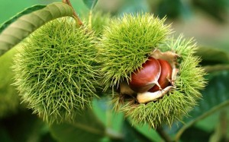

**What happens?**

Each year a yomatsuri (a kind of pre-festival festival) is held on September 27 before the main festival the next day. Besides eating chestnuts, the highlight is the 260 paper lanterns that light the area. Starting in 1925 and now in the present day, hand-drawn pictures are sketched on the lamps, which makes for a fun display.

For more on autumn sweets, see [here](https://tokyocheapo.com/food-and-drink/fall-food-japan/).

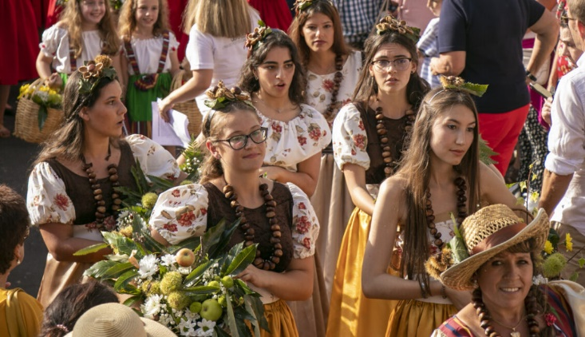

**Schedule 2023**

There will be street vendors and lanterns (moved to the following weekend in the case of rain) on both days of the festival from 9 a.m. to 9 p.m. There will also be dances in the Kagura Hall on the 28th at 3 p.m., 5 p.m., and 7 p.m. as well as floats on the same day at 5:30 p.m.